|  |  |  |  |  |  |  |
| --- | --- | --- | --- | --- | --- | --- |
|  | | | | | | |
| Conflict Resolution Day: Opportunities for Teachng Students How to ... | **Hot Lunch Options: Monday and Friday – Munch-A-Lunch (www.** **https://munchalunch.com/schools/montgomeryNB/)**  **Tuesday -Pizza**  **Thursday – Great Canadian Bagel**  **Milk is every day, except for Wednesday.**  **Please order on school cash online for pizza, bagels, and milk.** | | | | | |
| **MONDAY** | **TUESDAY** | **WEDNESDAY** | **THURSDAY** | | ***FRIDAY*** | |
| **Ms. Smith will be hosting the Rise and Shine program for students in grade 3-5.**  This is an early morning activity option for students to come into the gym and have some organized time to play a variety of games. We ask that students who choose to attend arrive between **7:20 and 7:30am on those Wednesdays. Doors will be locked at 7:31am.** | | | | | | |
| **September 30** **No School**  **Truth & Reconciliation Day** | **October 1** Wellness Week  Pizza Hot Lunch | **2** Rosh Hashanah  (Oct. 2-4)  Rise & Shine  begins | **3** **Great Canadian Bagel Hot Lunch – Every Thursday** | | **4**  *Munch-A-Lunch* | |
|  | |
| **7** Monty Movers Praise Assembly  *Munch-A-Lunch* | **8**  Pizza Hot Lunch | **9** | **10**  **MSS Terry Fox School Walk.**  **World Mental Health Day!** | | **11**  **Fruit Kabobs for Classes**  **Yom Kippur**  ***Munch-A-Lunch*** | |
| **14**  **No School**  **Thanksgiving Day** | **15**  Pizza Hot Lunch | **16** | **17** | | **18**  *Munch-A-Lunch* | |
| **KINDERGARTEN REGISTRATION FOR 2025-2026 Oct.14th-18th** | | | | | | |
| **21**  **Safe Schools Week – MSS will be practicing safety procedures all week!**  *Munch-A-Lunch* | **22**  **Vijaya Dashamt**  **Hindu Celebration** | **23**  **Last day to order POPCORN online!**  **Canadian School Library Day!** | **24** | | **25**  **POPCORN DAY**  Popcorn Bag Photos, Images & Pictures | Shutterstock  *Munch-A-Lunch* | |
| **Yom Kipper**  **Jewish Celebration**  **(24&25)**  Pizza Hot Lunch |
| **28**  *Munch-A-Lunch* | **29**  **Picture Retakes**  **(for those who booked through Harvey’s only)**  Pizza Hot Lunch | **30** | | **31**  Diwali  Halloween | |  |
| * Homework Reminder | Ms. Merino's Advanced Placement World HistoryVisitors/Parents must sign in at the office if they are entering the school * **Student Sign in at** office if arriving after 8:10am & sign out if leaving before early. * **Call the school if your child will be absent**. Please leave the reason and child’s first and last name. **453-5433** * **With October, comes colder mornings, it is always a great idea to bring a coat or sweater!** | | | | | | |

**LOOKING AHEAD**

**Nov. 6th  School Remembrance Day Assembly**

**Nov. 7th – Family Fun Cultural Night**

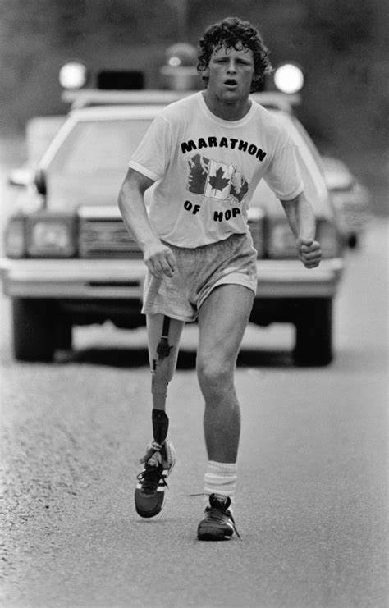 Terry Fox Walk

Our school Terry Fox Walk will be Thursday, Oct. 10th at 1:00pm. Students will walk some laps around the school to support Terry Fox and his dream. Our school is trying to fundraise $1000 to donate to the Terry Fox Foundation. Here is the link to support our school:

<https://schools.terryfox.ca/75200>.

A MESSAGE “From Guidance”

Mrs. Killam, Guidance Counsellor

As we begin another school year, I want to share a couple of back-to-school tips to help students and parents start the year off smoothly:

1. **Establish a Routine**: Set up a consistent daily schedule for homework, meals, and bedtime. A predictable routine helps children feel secure and can make transitions smoother. It also helps in developing good study habits and time management skills.
2. **Organize and Prepare**: Help your child get organized by setting up a dedicated study space and gathering all necessary school supplies. A well-organized environment can reduce stress and distractions, making it easier for students to focus and be productive.

These simple steps can pave the way for a successful and enjoyable school year!  Our goal at MSS is to create a positive and enriching environment where every student feels valued and empowered. If you have any concerns or need assistance, please don’t hesitate to reach out. Here’s to a successful and fulfilling year ahead!

Stacey Killam

**Nov. 8 – Professional Learning Day, No School**

**Nov. 11 – Remembrance Day, No School**

**Nov. 22 – Report Card Writing, No School**

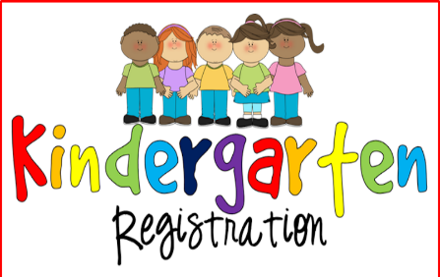

**OCT 14-18th**

**If you have a child who will turn five between now and December 31, 2024, it’s time to register him/her for kindergarten.**

[**LINK**](https://secure1.nbed.nb.ca/sites/ASD-W/kindergarten/Pages/default.aspx) **FOR ONLINE REGISTRATION**

[**https://asdw.nbed.ca/new- students/kindergarten/#how-to-register**](https://asdw.nbed.ca/new-%20%20%20%20%20%20%20%20%20students/kindergarten/#how-to-register)

**.**

**A MESSAGE “From the Gym”**

**Ms. Smith, P.E. Teacher**

**OCTOBER IS A BIG MONTH….**

**For Athletics!**

Our grades 3-5 Cross country runners will have their final cross- country races!

**The meet at O’Dell Park** is being held on **October 2nd**, and the district meet will be held at Nashwaaksis Middle School on October 9th. There is a rain date of Oct. 16th, 2024. Once cross-country finishes, badminton intramurals will start shortly after for our grade 3-5 students!

See Rise and Shine Information at the top of the page.



**Reminder - School fees are used to purchase additional student supplies & educational programs. This fee is due the first week of school.**

**If you have not paid yet, please pay $45.00 online per child to cover these costs.**