Montgomery Street School
School Supply List
2026-2027
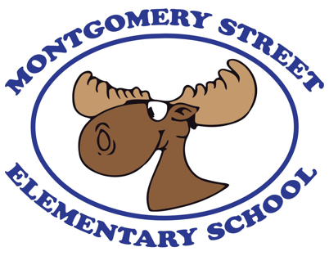

All students are asked to pay $60.00 to cover the cost of their school supplies and special projects.

The school will purchase all supplies which will save you money and time. Supplies purchased by the school are tax exempt, helping money go further.

School supply money is due your child’s first week of school and can be paid online through Cashless Schools.

In addition to the school fee, your child will need the following items on the first day of school:

- Indoor sneakers to stay at school (no laces in K-2, please). These sneakers must have proper support, traction, and non-marking soles as they must be appropriate for Phys. Ed.

- lunch box
1 backpack large enough to carry lunchbox and communication folder
1 reusable water bottle (there are water filling stations at school)

We look forward to seeing you in September!

